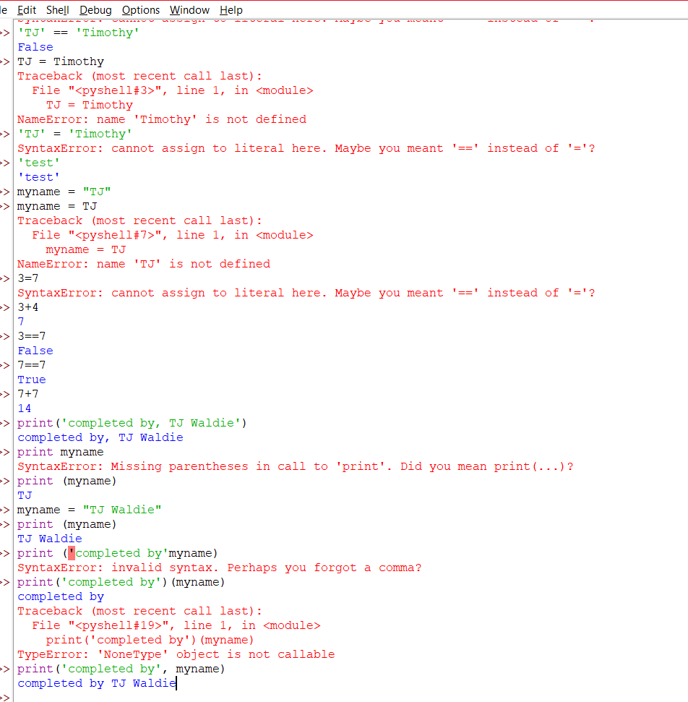

Python 3.12.5 (tags/v3.12.5:ff3bc82, Aug 6 2024, 20:45:27) [MSC v.1940 64 bit (AMD64)] on win32

Type "help", "copyright", "credits" or "license()" for more information.

'TJ'

'TJ'

'TJ' = 'Timothy'

SyntaxError: cannot assign to literal here. Maybe you meant '==' instead of '='?

'TJ' == 'Timothy'

False

TJ = Timothy

Traceback (most recent call last):

File "<pyshell#3>", line 1, in <module>

TJ = Timothy

NameError: name 'Timothy' is not defined

'TJ' = 'Timothy'

SyntaxError: cannot assign to literal here. Maybe you meant '==' instead of '='?

'test'

'test'

myname = "TJ"

myname = TJ

Traceback (most recent call last):

File "<pyshell#7>", line 1, in <module>

myname = TJ

NameError: name 'TJ' is not defined

3=7

SyntaxError: cannot assign to literal here. Maybe you meant '==' instead of '='?

3+4

7

3==7

False

7==7

True

7+7

14

print('completed by, TJ Waldie')

completed by, TJ Waldie

print myname

SyntaxError: Missing parentheses in call to 'print'. Did you mean print(...)?

print (myname)

TJ

myname = "TJ Waldie"

print (myname)

TJ Waldie

print ('completed by'myname)

SyntaxError: invalid syntax. Perhaps you forgot a comma?

print('completed by')(myname)

completed by

Traceback (most recent call last):

File "<pyshell#19>", line 1, in <module>

print('completed by')(myname)

TypeError: 'NoneType' object is not callable

print('completed by', myname)

completed by TJ Waldie